*You are receiving this email because you indicated interest in receiving updates on the revitalization of Uptown from the City of Centerville. Please feel free to forward this message or let anyone know to email me to be added to the list. Thank you!*

|  |
| --- |
| You are invited!  Uptown Public Meeting  Monday, March 13 5:30 – 6:30 p.m.  Centerville Police Department Training Room  155 W. Spring Valley Rd.  Join us for an open house to update residents, business owners and visitors about the latest in Uptown. This will include economic development, construction anticipated for 2023 and a possible timeline for the rest of the implementation plan. |

**Parking Lot Construction:**

Improving parking and reducing traffic congestion are two primary goals of the Uptown Action Plan. Below, you see a graphic that illustrates the City’s plan to construct a connected public parking lot behind businesses on the north side of West Franklin Street. Thank you to the many business owners who have the foresight to see the value in this plan and have signed a parking easement with the City. This will allow drivers to pass seamlessly through lots, simplifying their routes and relieving some traffic on roads. Additionally, the City will construct a public parking lot at 98 W. Franklin Street. Through a public process starting the week of March 13, companies will bid to complete that lot, as well as Phases 1 and 2 of the northern lot. City Council will award a contract in May; construction will likely begin in the spring and will be complete this year. There will still be ample parking in Uptown throughout construction.

This construction requires the City to cut down several trees, particularly along the back of the properties where the connected parking lot will be. We expect that work to begin in March 2023. We will replant dozens throughout the year in several locations throughout the community. If you are interested in learning more about our Tree City USA program, please join us at 11:00 a.m. on Thursday, April 27 at Activity Center Park.

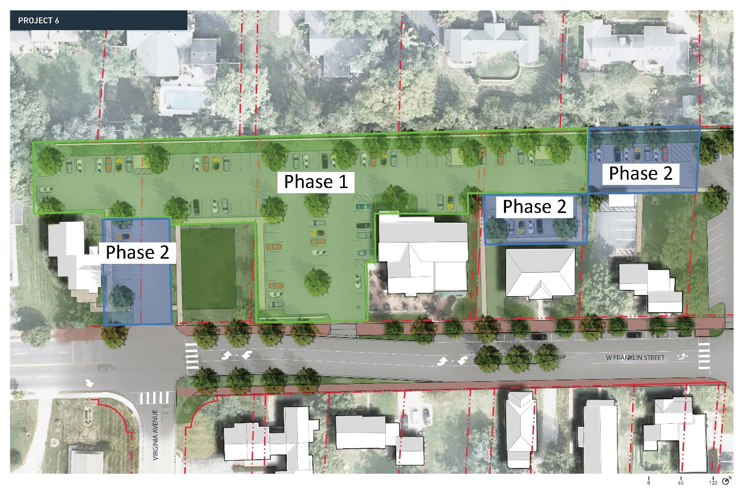

The connected northern lot on W. Franklin St.

Construction drawings showing public lot planned for 98 W. Franklin St.

**Parking Lot Names:**

Help us name our parking lots! Fun? Funny? Historical?  
Please make a suggestion here! <https://bit.ly/3KVH5Vo>

**Economic Development:**

* **Manna**, an upscale restaurant offering Peruvian cuisine with a French influence, is nearing the end of construction on West Franklin Street. Owner Margot Blondet also operates Salar in downtown Dayton and plans on a spring opening in Centerville.
* An early summer opening is in the plans for **Agave & Rye**, a taco and tequila restaurant under construction next to Square One on North Main Street.
* Work has begun on **Brunch Pub**, which moves closer daily to welcoming customers on West Franklin Street. Owner Ali Bas describes the full-service menu as “moderately priced ‘comfort’ food influenced by Italian, French and American cooking traditions.”

You can read the full Uptown Action Plan and see several more concept images at centervilleohio.gov/uptown. Please send any comments or questions to [kbostdorff@centervilleohio.gov](mailto:kbostdorff@centervilleohio.gov).

We hope to see you at the Uptown Public Meeting on Monday, March 13 at 5:30 p.m.!